**CS399 - Seminar**

**20-minute video**

Tarusi Mittal 1901CS65

To watch the video, click on the link given below:

<https://drive.google.com/file/d/1C2TxBDT-p_WrBWr8lnLeLoNe-wcp_y5u/view?usp=sharing>

However, as the file size is big so some prompts like this can appear:

***If you are viewing on tablet or phone please see the next page.***

1. If you are viewing on the laptop:

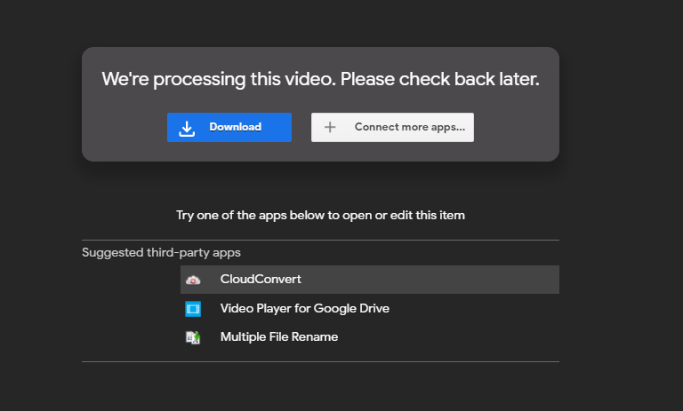

Click on the blue download button.

1. After this another prompt might appear

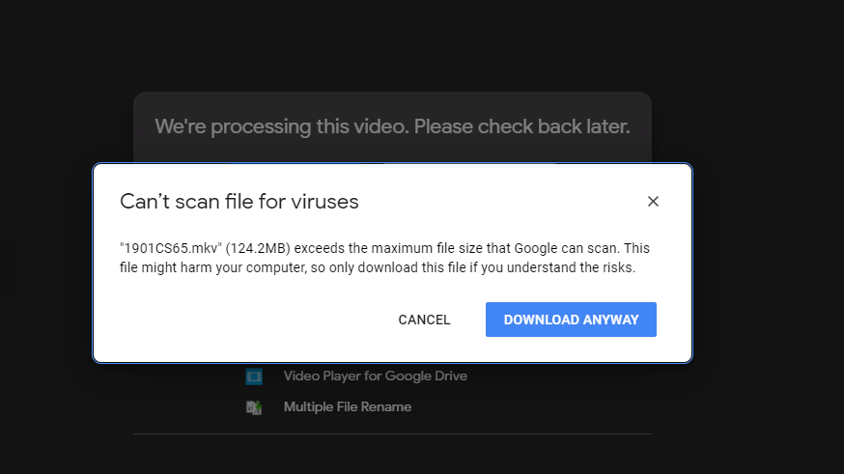

Here click on download anyway option.

1. If you are viewing on a phone or tablet first it can show that the video cannot be played but you need to click the three dots on the right upper corner.
2. Then a dropdown like this will appear and you need to click download.
3. Then the video will be downloaded on your device and you can access it in your files by the name of 1901CS65_TarusiMittal.mkv

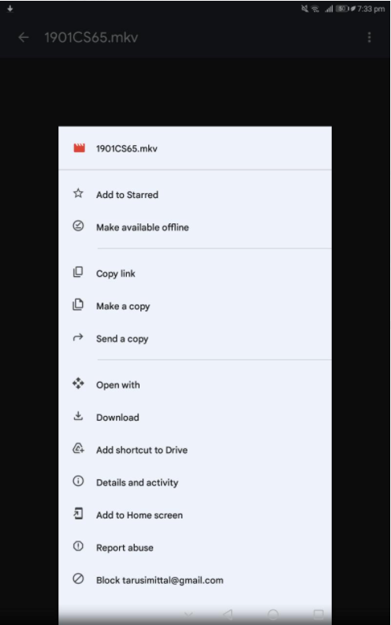

3 Dots